Work report 3 sep 2021

Today I have trained the mask rcnn syncbn model till 80000 epoch with augmentation

The evaluation results are as follows

1. Test Data

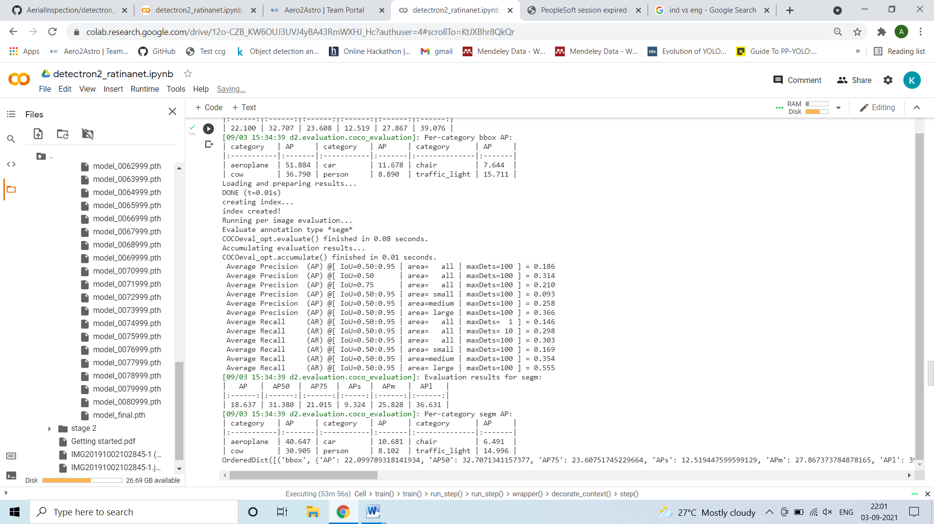

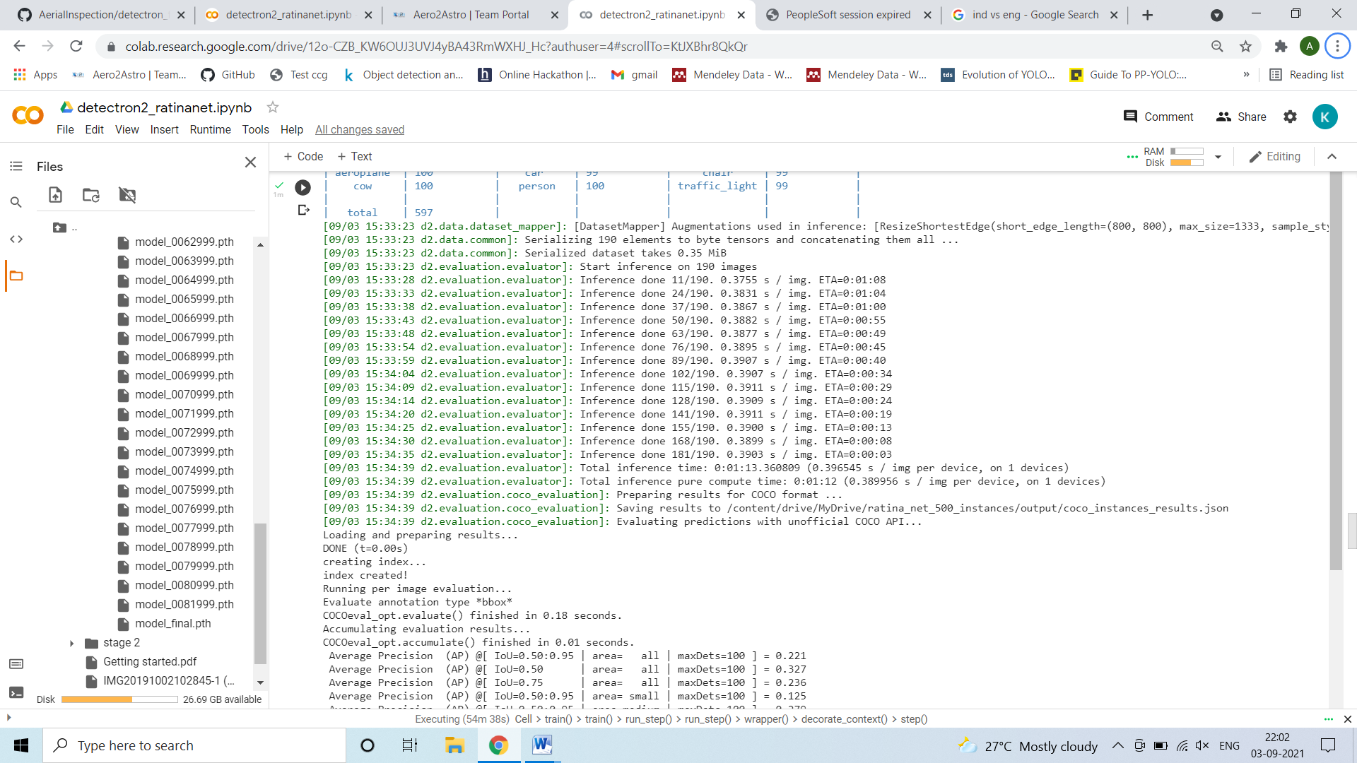

Train

